Integrating the Healthcare Enterprise



IHE <Domain Name>

Technical Framework Supplement

<Profile Name
(Profile Acronym)>

< Public Comment or
Trial Implementation>

Date: <June XX, 200X>
Author: <Charles Parisot>
Email: <ihe@himss.org>

This is a supplement to the IHE <Domain Name> Technical Framework <VX.X>.

It is submitted for Public Comment between <June 15, 2008 and July 15, 2008>.
Comments shall be submitted within that period to http://forums.rsna.org:
- Select the “IHE” forum
- Select <Domain Name> Technical Framework
- Select <2008-2009> Supplements for Public Comment
- Select <Supplement Name>
Please use the Public Comment Template provided there when starting your New Thread.

Details about IHE may be found at: www.ihe.net

Details about the IHE <Domain Name> may be found at: http://www.ihe.net/Domains/index.cfm

Details about the structure of IHE Technical Frameworks and Supplements may be found at: http://www.ihe.net/About/process.cfm and http://www.ihe.net/profiles/index.cfm

The current version of the IHE <Domain Name> Technical Framework may be found at:. http://www.ihe.net/Technical_Framework/index.cfm

These ”boxed” instructions are for the author to indicate to the Volume Editor how to integrate the relevant section(s) into the overall Technical Framework
Replace Section X.X by the following:
TABLE OF CONTENTS
Introduction 3
Profile Abstract 3
Open Issues and Questions 3
Closed Issues 3
Volume 1 – Integration Profiles 4
Glossary 4
1.7 History of Annual Changes 4
2.1 Dependencies among Integration Profiles 4
2.2.X <Profile Name> Integration Profile 4
X <Profile Name> Integration Profile 4
X.1 Actors/ Transactions 4
X.2 <Profile Name> Integration Profile Options 6
X.3 <Profile Name> Process Flow 6
X.4 <Profile Name> Security Considerations 7
<Appendix A> Actor Summary Definitions 7
<Appendix B> Transaction Summary Definitions 8
Volume 2 - Transactions 9
3.Y <Transaction Name> 9
3.Y.1 Scope 9
3.Y.2 Use Case Roles 9
3.Y.3 Referenced Standard 9
3.Y.4 Interaction Diagram 9
<Appendix letter> Appendix_Name 11

Introduction
<provide a brief overview of the volumes/ sections of the Technical Framework that get changed/ added by this profile>

Profile Abstract
<200 words or less describing this profile – goes in Executive Summary document>

Open Issues and Questions
< List of open issues/ questions that need to be addressed prior to publishing of the Technical Framework>

Closed Issues
< List of closed issues/ questions with their resolutions that have been addressed prior to publishing of the Technical Framework>

Volume 1 – Integration Profiles

Glossary
Add the following terms to the Glossary:
<any glossary additions associated with the profile draft go here>

1.7 History of Annual Changes
<Brief overview of “what’s new” in the given year of the Technical Framework.>
Add the following bullet to the end of the bullet list in section 1.7
- Added the XYZ Profile which does blah, blah, blah…..

2.1 Dependencies among Integration Profiles
Add the following to Table 2-1

<Profile Name> | <?> | <?> | <->

Add the following section to section 2.2

2.2.X <Profile Name> Integration Profile
<One paragraph description/ overview of Integration Profile>

Add Section X

X <Profile Name> Integration Profile
<Introductory Description/ overview of Integration Profile. May be the same as 2.2.X if that’s all it takes.>

X.1 Actors/ Transactions
<Actor/ Transaction diagram and Actor/ Transaction table. >
Figure X.1-1 shows the actors directly involved in the <Profile Name> Integration Profile and the relevant transactions between them. Other actors that may be indirectly involved due to their participation in <other related profiles>, etc. are not necessarily shown.

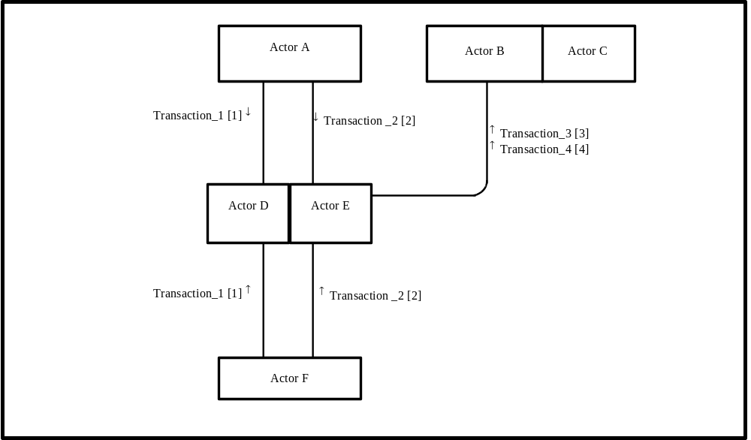
Figure X.1-1. <Profile Name> Actor Diagram
Table X.1-1 lists the transactions for each actor directly involved in the <Profile Name> Profile. In order to claim support of this Integration Profile, an implementation must perform the required transactions (labeled “R”). Transactions labeled “O” are optional. A complete list of options defined by this Integration Profile and that implementations may choose to support is listed in Volume I, Section X.2.

Table X.1-1. <Profile Name> Integration Profile - Actors and Transactions
Actors | Transactions | Optionality | Section in Vol. 2
Actor A | Transaction_1 | R | Z.1
Actor A | Transaction_2 | R | Z.2
Actor F | Transaction_1 | R | Z.1
Actor F | Transaction_2 | R | Z.2
Actor D/ Actor E | Transaction_1 | R | Z.1
Actor D/ Actor E | Transaction_2 | R | Z.2
Actor D/ Actor E | Transaction_3 | R | Z.3
Actor D/ Actor E | Transaction_4 | R | Z.4
Actor B (Actor C) | Transaction_3 | R | Z.3
Actor B (Actor C) | Transaction_4 | R | Z.4
Note: This is a note

X.2 <Profile Name> Integration Profile Options
<Table describing the options available for this integration profile and references to all sections that state requirements for compliance to the Option.>
Options that may be selected for this Integration Profile are listed in the table X.2-1 along with the Actors to which they apply. Dependencies between options when applicable are specified in notes.
Table X.2-1 <Profile Name> - Actors and Options
Actor | Options | Vol & Section
Actor A | No options defined | - -
Actor F | No options defined | - -
Actor D/ Actor E | No options defined | - -
Actor D/ Actor E | No options defined | - -
Actor B (Actor C) | No options defined | - -
Actor B (Actor C) | No options defined | - -

X.3 <Profile Name> Process Flow
<Description of the process flow(s) and sequence diagram(s) covered by this profile in order to satisfy the use cases. This often will include a brief description of the use cases as well. If there are detailed behavioral rules that apply to a specific process flow or multiple process flows or descriptions then an appendix may be added as needed>

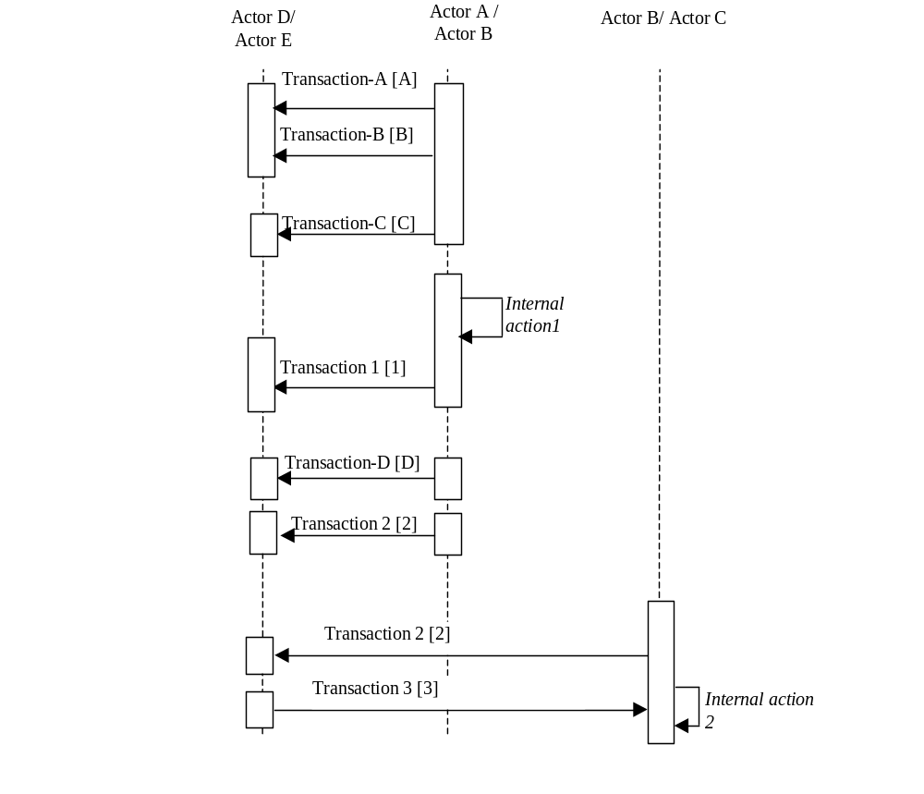
Figure X.2-1. Basic Process Flow in <Profile Name> Profile

X.4 <Profile Name> Security Considerations
<Description of the Profile specific security considerations. This should include the outcomes of a risk assessment. This likely will include profile groupings, and residual risks that need to be assigned to the product design, system administration, or policy.>
<Appendix A> Actor Summary Definitions
<add any actor definitions for new actors defined specifically for this profile>
<Appendix B> Transaction Summary Definitions
<add any transaction definitions for new transactions defined specifically for this profile>

Volume 2 - Transactions
Add section 3.Y

3.Y <Transaction Name>
This section corresponds to Transaction Y of the IHE Technical Framework. Transaction Y is used by the <ABC> and <DEF> actors.

3.Y.1 Scope

3.Y.2 Use Case Roles
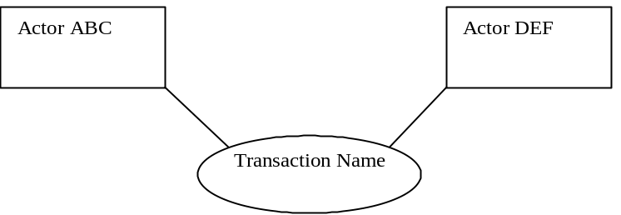

Actor:
Role:
Actor:
Role:
Actor:
Role: .

3.Y.3 Referenced Standard
<e.g., HL7 2.3.1 Chapters 2, 3>
<e.g. DICOM 2008 PS 3.3: A.35.8 X-Ray Radiation Dose SR IOD>

3.Y.4 Interaction Diagram
<the interaction diagram shows the detailed standards-based message exchange that makes up the IHE transaction>
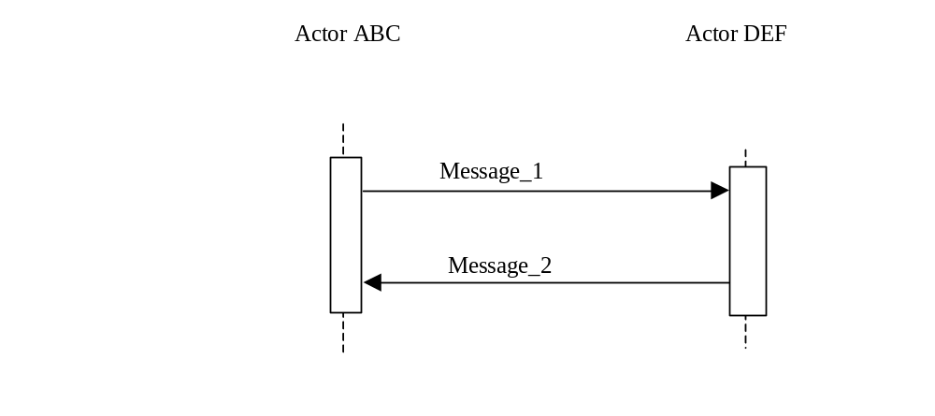

3.Y.4.1 <Message_1 Name>
<One or two sentence description of the first message of the above interaction diagram, typically relating the message to the relevant standard>

3.Y.4.1.1 Trigger Events
<description of the real world events that cause the initiation of the first message>

3.Y.4.1.2 Message Semantics
<detailed description of the meaning, structure and contents of the first message including any IHE specific clarifications of the message format, attributes, etc.>

3.Y.4.1.3 Expected Actions
<description of the actions expected to be taken as a result of sending or receiving this message>

3.Y.4.2 <Message_2 Name>
<One or two sentence description of the the next message in the above interaction diagram, typically relating the message to the relevant standard. Note, repeat this section as necessary based on the number of messages in the interaction diagram>

3.Y.4.2.1 Trigger Events
<description of the real world events that cause the initiation of the next message>

3.Y.4.2.2 Message Semantics
<detailed description of the meaning, structure and contents of the next message including any IHE specific clarifications of the message format, attributes, etc.>

3.Y.4.2.3 Expected Actions
<description of the actions expected to be taken as a result of sending or receiving this message>

3.Y.5 Security Considerations
<description of the transaction specific security consideration. Such as use of security profiles. >

3.Y.5.1 Security Audit Considerations
<This section should specifiy any specific ATNA security audit event that is associated with this transaction and requirements on the encoding of that audit event. >

3.Y.5.1.(z) Actor Specific Security Considerations
<This section should specifiy any specific security considerations on an Actor by Actor basis.>
<Appendix letter> Appendix_Name
<Detailed cross transaction relationships or mapping details are described in an appendix in Volume 2>

